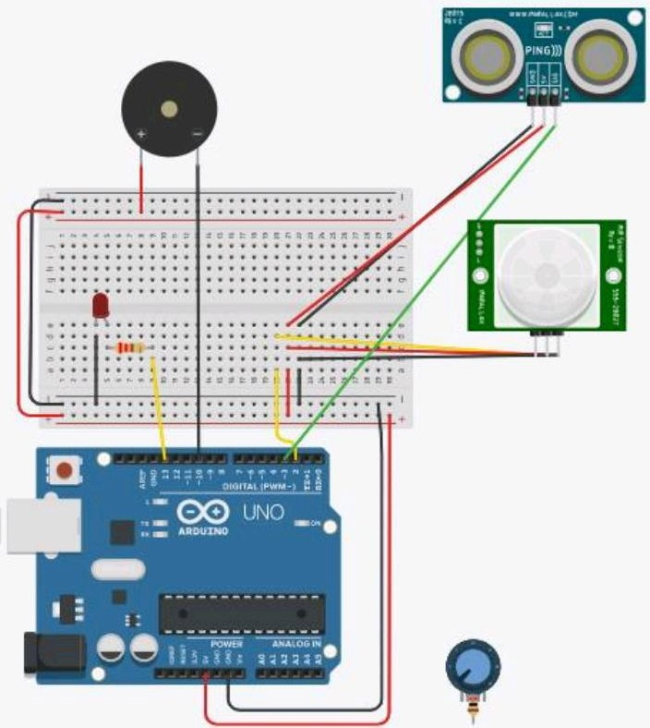-

D 13

BfJEl

#include <Servo.h> Servo myservo; canst int PIR = 2; canst int LED= 13;

canst int BUZZER = 10; int pir_a = O;

void setup() { pinMode(LED, OUTPUT);

pinMode(BUZZER, OUTPUT);

pinMode(PIR, INPUT); Serial.begin(9600); myservo.attach(3);

}

void loop() {

pir_a = digitalRead(PIR); if (pir_a == HIGH) { digitalWrite(LED, HIGH);

digitalWrite(BUZZER, LOW); Serial.println("detecting"); myservo.write(180};

}

else {

digitalWrite(LED, LOW); digitalWrite(BUZZER, HIGH); Serial.println("no movement"); myservo.write(-180);

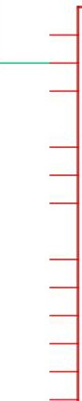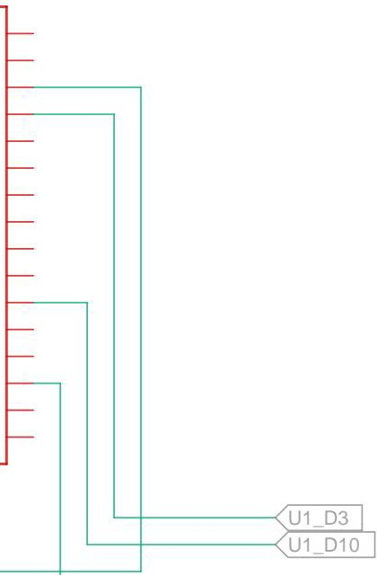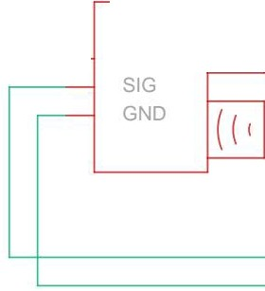

|  |  |  |  |
| --- | --- | --- | --- |
| 3 **4 6** | | | |
| **A**  **B**  **C**  **D**  **E** | U1_5V  ,4>--.,.. <u1_sv  U1  PIR123  RES D6  POT3 POT2 POT1 ,,,,,, C1 R2 R1 Svec AO Arduino ;  **--c::::::J-- --c::::::J-- --c::::::J--** --t>f-- **---ll-** ---c:::J- OUT A1 UNO D9  250k 250k 250k D2 100n 1k 220 D1 GND  RED RED D11 D12  SDA  SCL  '----------...--- ,., _,., <U1_GND  U1_GND  U1 5V  PING2  @:],))  U1 D10 U1 D3 U1_GND | | **A**  **B**  **C**  **D**  **E** |
| **Made with Tinkercad®** | **Title: smart home sensor** |
| **Date: 9/15/2022, 3:40:54 PM Sheet: 1/1** |